AIITRA Robotics Challenge 2021

# Team Name : TechKnights' Alliance

# Team Members :

|  | Name of Member | Roll number | Email ID | Contact Number | Team Subsystem |
| --- | --- | --- | --- | --- | --- |
| 1 | Kirtan Patel | AE19B038 | ae19b038@smail.iitm.ac.in | 83479 49700 | Path Optimization |
| 2 | Kahan Lakhani | ME19B120 | me19b120@smail.iitm.ac.in | 90992 50248 | Robot Designing |
| 3 | Nisharg Manvar | EE19B094 | ee19b094@smail.iitm.ac.in | 99250 10703 | Path Optimization |
| 4 | Harish R | EE20B044 | ee20b044@smail.iitm.ac.in | 97863 24868 | Electronics |
| 5 | Dhruv Maroo | CS20B025 | cs20b025@smail.iitm.ac.in | 81412 31731 | Simulations |

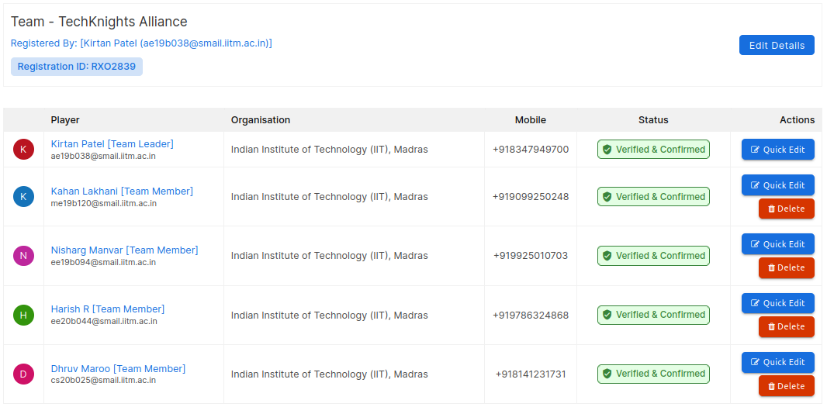

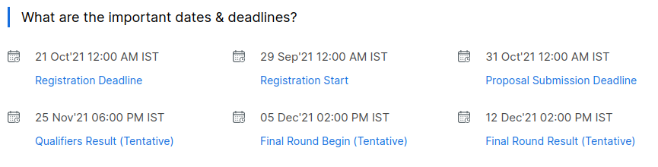

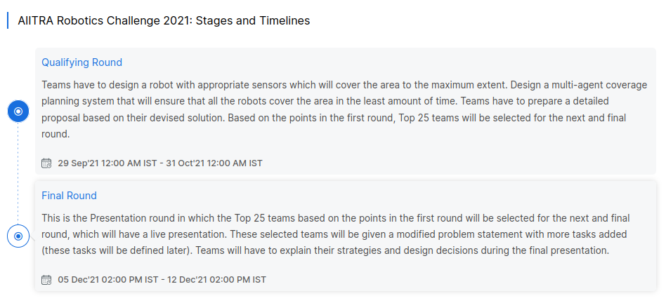

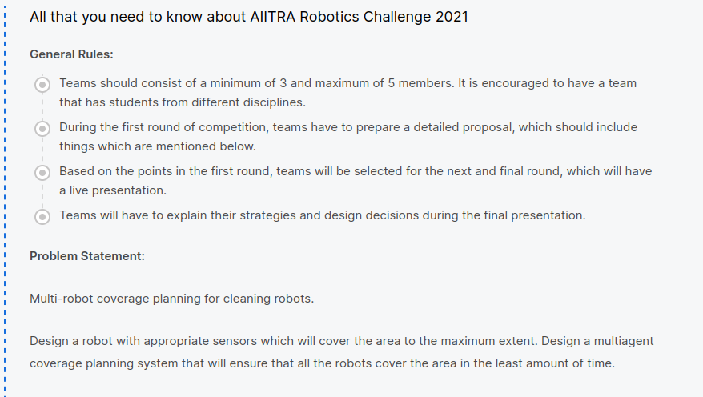

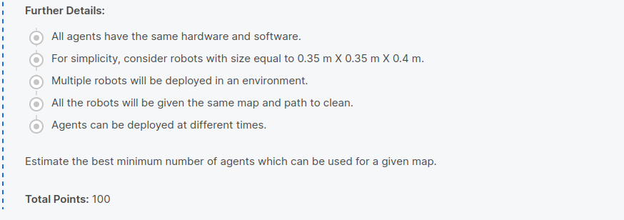

For detailed explanation, refer Problem Statement uploaded on the Drive

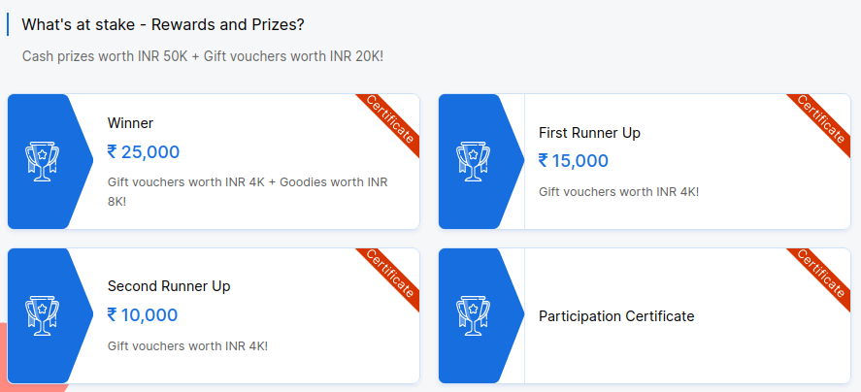

# Submission

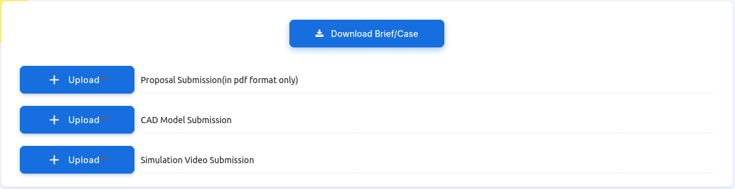

# Course of Action

1. Robot Designing

* Detail the dimensions of the given maps.
* Decide Motion Controls
* Design the robot
  + Dimensions
  + Mass
  + Strength
  + Material
* Decide Dynamics Constraints based on the design
* Encompass Sensors, onboard computer etc in the design parameter
* Model the bot

2. Path Planning

* Map Decomposition
* Complete Coverage Algorithms
* Application of Complete Coverage Algorithm based on Motion control constraints
* Constraint on Dynamics **
* Location and Number of deployed Bots
* See efficiency of Algorithms across Maps **
* Decide if same or different algorithms across maps

3. Electronics

* Consolidate detailed information about the sensors used
  + Distance,
  + speed,
  + Acceleration,
  + Navigation,
  + gyro etc
* Understand how Sensor Fusion can be used for Integrated Navigation Path Correction
* Understand Robotics Hardware Stack and implement it
* Finalize Hardware used and space allocation needed on the bot
* Document the data relay system and working.

4. Simulations

* Understand URDF and Launching Worlds. ( or convert model from CAD to URDF; if you prefer CAD )
* Generate Launch files for each of the world as per detailed dimensions
* Generate URDF for the designed Bot
* Launch the World. Spawn the Bot in the world.
* Work on and Set-up code controlled Telemetry
* Generate Code for the finalized Algorithm
* Execute and Record the Simulations for each world.
* Understand Robotics Software Stack and its implementation

# Guidelines

1. Upload all the documents which you refer to, while working, on the drive in your respective folders.
   1. Use proper number and title for the documents uploaded for ease of reference.
   2. If needed, form subfolders for each task which you carry out.
2. Maintain proper documentation of your work by making a separate Google Doc. Upload that too.
3. Update the Team Doc on your work progress.
   1. Keep in touch with the team members.
   2. A lot of tasks are interrelated so share your POVs and inputs with the team on a regular basis.
4. We are working on a tight schedule, so you will need to work extra hours to meet the deadlines
5. If you have any queries or questions, feel free to message on the Whatsapp group.

We are aiming for a bot which uses Navigation and distance sensors. Unlike traditional robovacs it will not bump into obstacles and change course.

This will enable us to cover the area on a much shorter time by not having to reduce the limit on our maximum velocity, fearing collision

Please keep this in mind when designing the bot and working on the sensors, and sensor placements

This is also due to the fact that we will have multiple robots on the map and hence random motion will not contribute to coverage efficiency in a lesser amount of time

Our Robovacs are not equipped with GPS. We know the map and the initial Deployment positions. After this, we will be using the actuator command to estimate the robot position + distance sensor to verify it.

Please consider this in and refer to the MATLAB TechTalk Playlist on [Sensor Fusion](https://www.youtube.com/playlist?list=PLn8PRpmsu08ryYoBpEKzoMOveSTyS-h4a).

Round 2

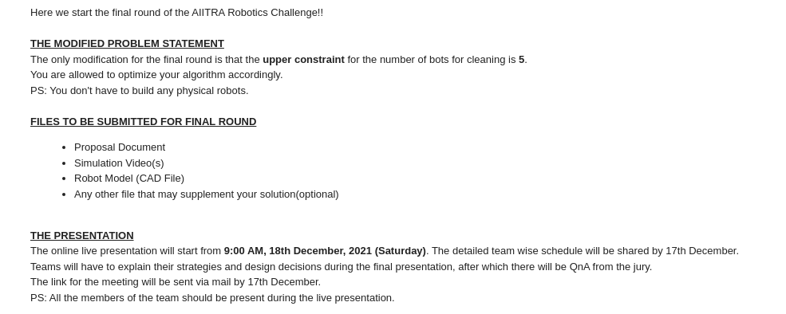

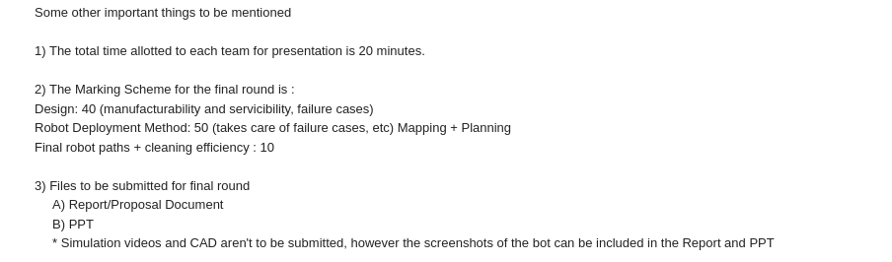

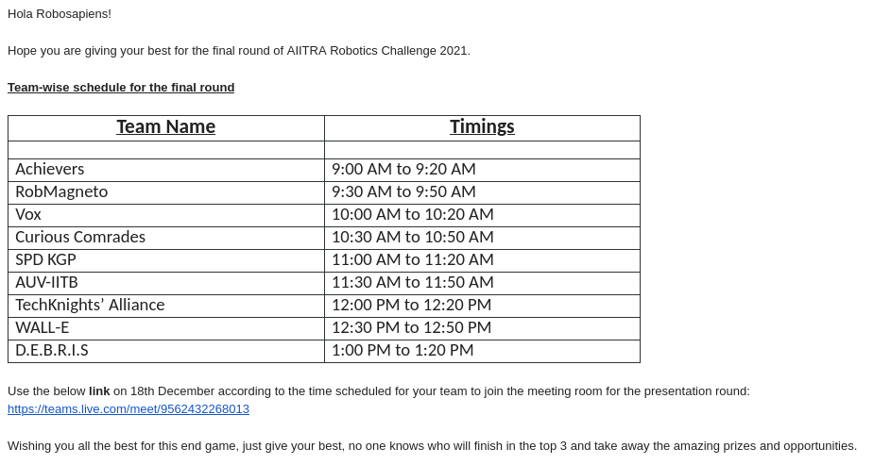

# Course of Action

1. Robot Designing

* Manufacturability - ….
* Serviceability - ….
* Failure Cases

2. Path Planning

* Robot Deployment Method - reasons, outcomes (Mapping??), Planning
* Final Robot Paths
* Cleaning Efficiency

3. Electronics

* Manufacturability - ….
* Serviceability - ….
* Failure Cases

4. Simulations

* TBD

